# Exercise 12: Prompting People for Numbers

1. Try out the .to_f operation. What does .to_f do?

**print "Enter Number: "**

**n = gets.chomp.to_f**

**puts "The floating number is #{n}"**

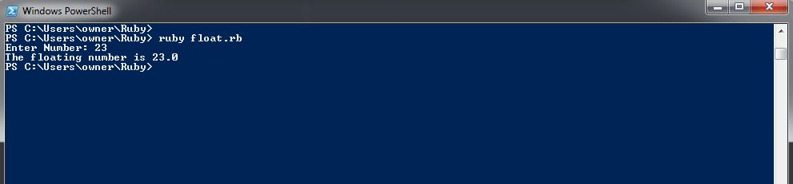

1. To play with .to_f more, make a small script that asks for some money and gives back 10% of it. If I give your script 103.4 (dollars), your script gives me back 10.34 in change.

**puts "Enter some Money"**

**n = gets.chomp.to_f**

**m = n*0.10**

**puts "Your change is #{m.round(2)}"**

